**LAM CHI KWAN, RIKA** 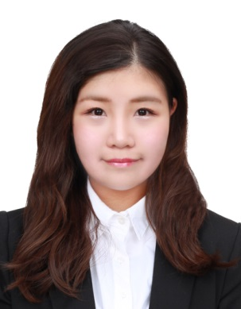

|  |  |  |  |
| --- | --- | --- | --- |
| Personal Information | | | |
|  | | | |
| Date of Birth | : | 21 Feb 1994 |
| Gender | : | Female |
| Languages | : | Chinese, English, Putonghua |
| Phone No | : | 63906907 |
| Email | : | rikalck@hotmail.com |
| Availability | : | Immediate |
| Present Salary | : | HKD15,800 |
| Expected Salary | : | HKD17,500 |

|  |
| --- |
| Career Objective |

* Seeking a challenging career with a progressive organization that provide an opportunity to capitalize my technical skills & abilities in the fields of secretarial and administrative management.
* Enthusiastic and proactive in communicate with different kinds of people.

|  |
| --- |
| Education |

* **The Open University Of Hong Kong** 2014 – 2016
  + Bachelor of Business Administration in Human Resource Management
* **Lingnan Institute of Further Education** 2012 – 2014
  + Higher Diploma of Event Management
* **Tang Shiu Kin Victoria Government Secondary School (F.1 – F.6)** 2006 – 2012

|  |
| --- |
| Work experience |

* + **W.H.S. Consultants Limited (Accounting firm)** Jun 2017 – Sep 2018
    - Junior Company Secretary
      * Assist director for daily operations and personal issues
      * Organize the files for infrastructural system
      * Communicate with contractor and clients
      * Admin work
      * Issue invoice
  + **Top Express Enterprise Group Limited** Apr 2016 – Jun 2017
    - Project Officer
      * Admin work
      * Company secretarial work (prepare for legal documents)
      * Handle for tax matters
      * Maintain relationship with customer (mainly in China and Indian)

|  |
| --- |
| Other skills |

* + **Language**
    - Fluent in written and spoken English, Cantonese and Mandarin
  + **Data Entry:** 
    - Chinese 35 WPM English 50 WPM
  + **Computer skills:** 
    - Proficient in MS Word, Excel, PowerPoint
  + **Other:** 
    - Proven sales and negotiation skills
    - Able to work individually or in a team
    - Owned driving license type 1